Visitors in Cambridge complain about finding the bus that would take them to their destination. They often have to spend a lot of time looking for the bus they need to take. They even have to ask the bus drivers about the bus which would take them to their stop. This causes time delays as the drivers have to explain where they would find the desired bus and wastes everybody’s time and is highly inefficient. I have stepped in to offer some help. For my project I will design and program a desktop application that will enable the user to find the desired route. Stagecoach manager expects the program to find the best route between bus stops in an efficient way.

A representation of a graph data structure:

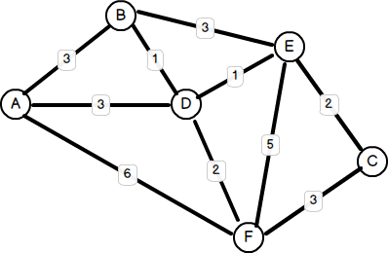Each stop will be a vertex storing the bus number that stops on the bus stop. There will be time between the nodes. These connections are called edges.

I could use a table to store each of the values, i.e. vertexes v edges. I need to do more research on it though. I need to learn how to implement a graph data structure in C#.

There are algorithms for finding the shortest path possible like the Dijkstra's Shortest Paths. More algorithms can be found in this link: <http://www.boost.org/doc/libs/1_56_0/libs/graph/doc/index.html>

I need to look at the theory as well and see how much more memory is taken up by adding a node or an edge. On Wikipedia there is a nice table showing how the complexity rises when give n nodes and a edges. (<http://en.wikipedia.org/wiki/Graph_(abstract_data_type)> )

My application needs to be user friendly enough so that a user can easily navigate through it. It needs to be fairly responsive so that it takes a relatively short amount of time to calculate the optimal.

To expand the program I could introduce more cities because Stagecoach is not only used in Cambridge but other 400 towns and cities in UK. The information about the bus stops and buses in Cambridge can be found on their website ( <http://www.stagecoachbus.com/timetable-landing.aspx> ) in a table format which can be easily copied and pasted. The software can also be expanded further giving information about the buses and ticket prices as well as an option of a map a user can click on to choose destinations.

My user is Joe Johnson.